***Task description***

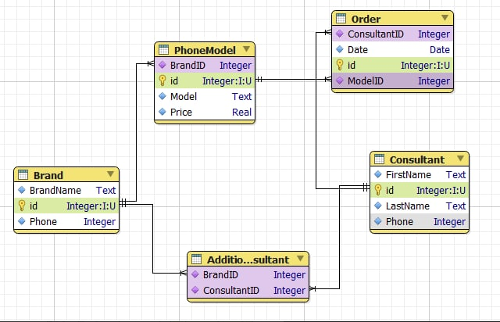

* purple are marked Foreign key (FK);
* green are marked Primary key (PK);
* all PK with autoincrement;
* all fields are required;
* an additional «Additional_Brand_Consultant» table is used to create relationship a many to many with tables «Consultant» and «Brand».